Create a sh file like

#!/bin/sh
value=$(netstat -A inet -p| grep ESTA|grep -v "chrome\|firefox\|vmplayer\|gateway:bootps\|splunk\|broadband\|fdm\|python\|mongod\|wenative\|wpsoffice\|systemd[-]resolve\|.ac:domain\|hypnotix\|java\|scrcpy\|adb" | awk '{print $7, $1, $4,"-->", $5}')
# netstat -A inet -p| grep ESTA | awk '{print $7, $1, $4,"-->", $5}'|awk '$1!~/chrome|firefox|hypnotix/'
if [ -n "$value" ]
then
/usr/bin/notify-send "network connection" "$value" # -u critical -t 5000
fi
exit

note: can update the codewith required whitelist process

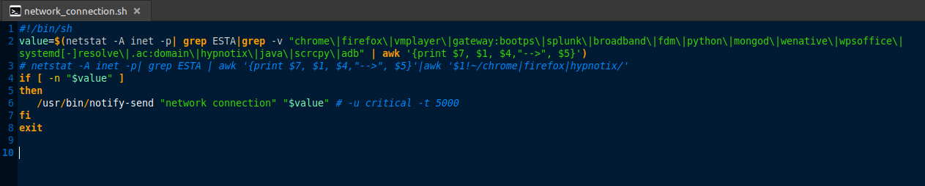

Open a crontab using crontab -e
Add entry like
DISPLAY=":0.0"
XAUTHORITY="/home/nandu/.Xauthority"
XDG_RUNTIME_DIR="/run/user/1000"
* * * * * /home/nandu/my_linux/cron_tab/network_connection.sh

this will make the shell script run every 1 minute and check for any open network connection.

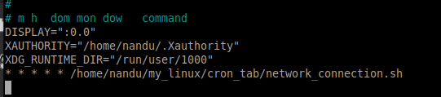

result

